MPCA: Lab - 7

Name: Rithvik Rajesh Matta
SRN: PES2UG23CS485
Sec: H

- Write an ALP to set the LED to light up.

Left On:
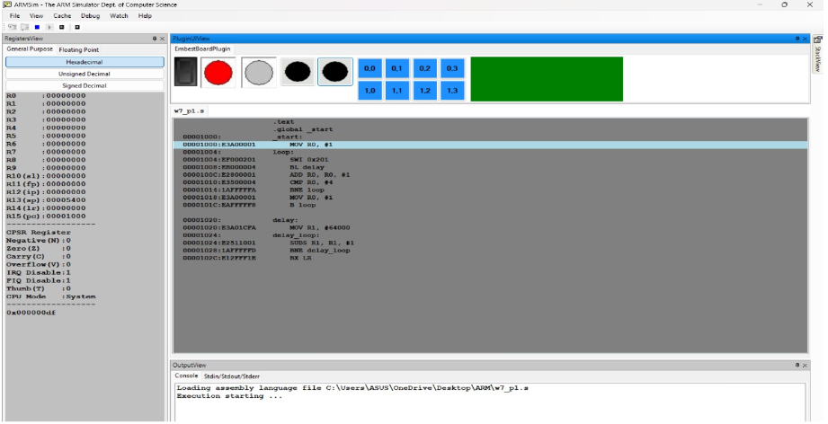

Right On:

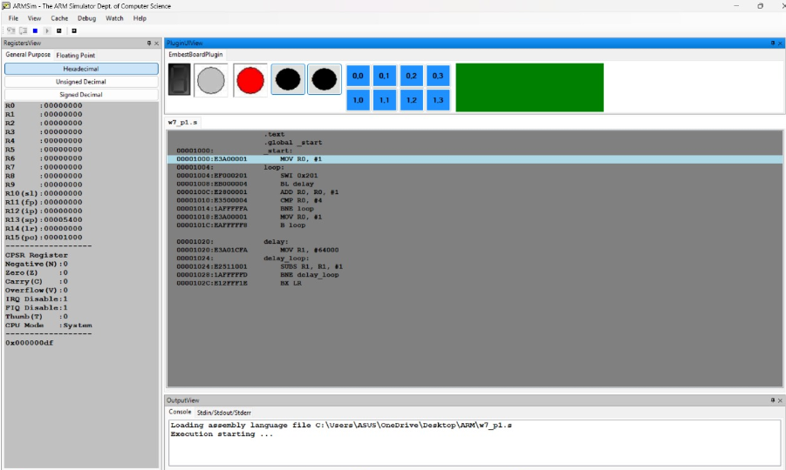

Both On:
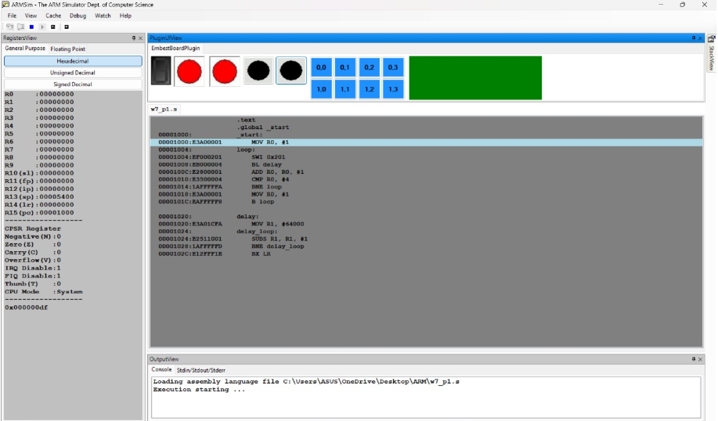

- Write an ALP to display 0 to F and F-0 on the 8 segment display depending on the which black button is pressed.

When no button is clicked:
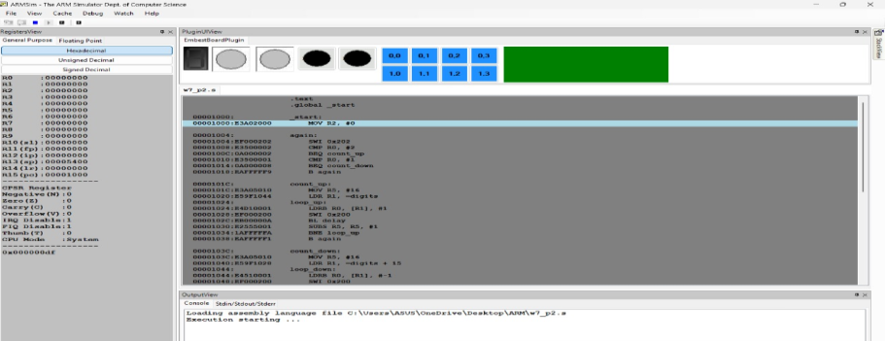

When left button is clicked:
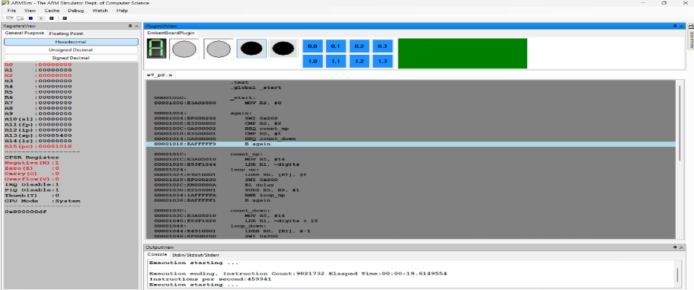

When right button is clicked:
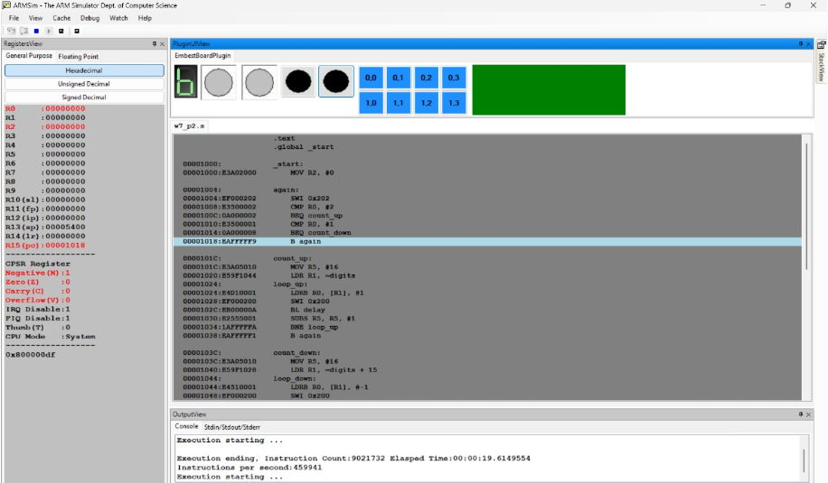

- Move a string left to right, right to left on LCD in Embest Board.

